How to Configure High Availability in XenServer

Document ID: CTX118545
This article describes how to enable High Availability on XenServer.
Requirements
Before configuring high availability (HA) on a resource pool, validate the requirements are satisfied for all servers and virtual machines in the pool:
- Shared storage is available, including at least one iSCSI or Fibre Channel LUN of 356MB or greater. This LUN will be used for the heartbeat SR.
- Adequate licenses are installed on all servers.
- Only agile virtual machines might be protected by HA. For VM this means:
  - Virtual disks must be on shared storage. Any type of shared storage may be used; the iSCSI or Fibre Channel LUN is only required for the storage heartbeat and can be used for virtual disk storage if you prefer, but this is not necessary.
  - Virtual network interfaces must be on pool-wide networks.
  - Virtual machines must not have a connection to a local DVD drive configured.
We strongly recommend the use of a bonded management interface on the servers in the pool if HA is enabled, and multipathed storage for the heartbeat SR.
Procedure
To enable High Availability, complete the following procedure:
- Select the pool in the Resources pane, click HA tab, and then click Enable HA.
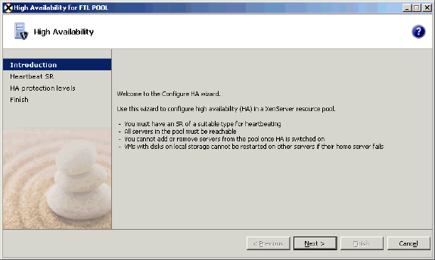
Or
  - On the Pool menu, click High Availability.
  - Right-click the Resources pane and click High Availability.
2. Click Next. XenCenter scans the pool for a shared iSCSI or Fibre Channel LUN that can be used as the pool's heartbeat Storage Repository (SR) before displaying the next wizard page.
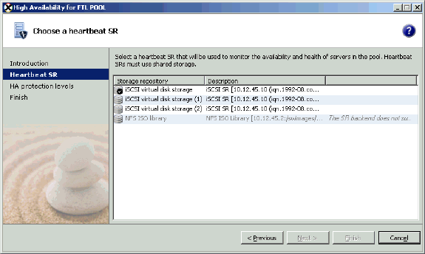
- If no suitable SR is found, configure the new storage before continuing to configure HA.
- Choose a heartbeat SR from the list, and click Next.
- For each virtual machine you wish to protect, set the protection level by completing any of the following steps:
Selecting the VM and then click one of the buttons to the right of the list.
Or
Right-clicking in the list and using the shortcut menu.
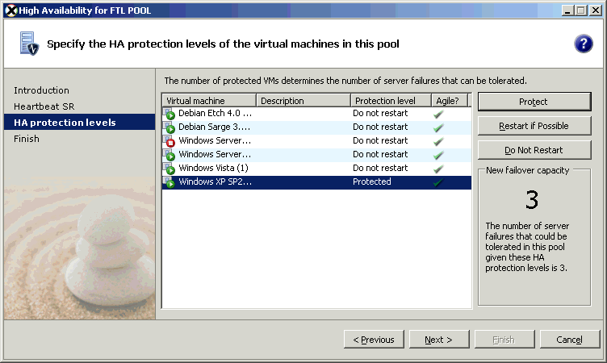
  - To select more than one virtual machine, click at the start of the selection, press and hold the SHIFT key, and scroll to the end of the selection.
  - To select several virtual machines that are not adjacent in the list, select the first VM, press and hold the CTRL key, and then click the additional virtual machines that you want to select.
  - Select Protect to ensure HA protection for the selected VM.
  - Select Restart if Possible if it is not essential to restart the virtual machine automatically. Virtual machines with this protection level are not guaranteed to be restarted. However, if they are believed to have failed and if there is sufficient resource available after all other protected virtual machines have been successfully started, they will be restarted on a live server. Restart if possible is the only restart priority available to non-agile virtual machines, that is, virtual machines that have local storage or that have a connection to a local DVD drive configured or that have local virtual network interfaces.
  - Select Do Not Restart if you never want the virtual machine to be restarted automatically.
  - The failover capacity for the pool, the resources available, and the protection levels you have specified are shown on the right of the list of virtual machines.
- Click Next when you have finished virtual machine protection configuration.
- On the last page of the wizard, you can review your HA configuration.
Click Back to go back and change any of the settings.
Click Finish to close the wizard and enable HA for the pool.
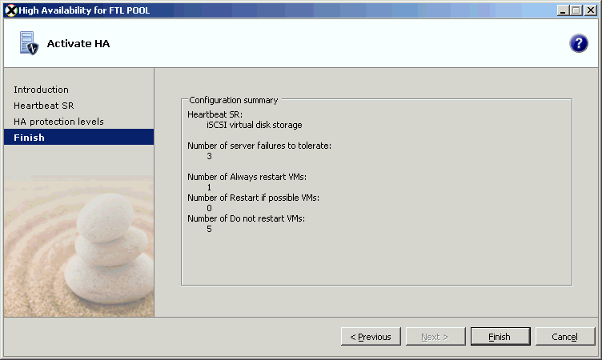

This document applies to:
- XenServer 5.0
- XenServer 5.0 Update 3
- XenServer 5.5
- XenServer 6.0
- XenServer 6.1.0
- XenServer 6.2.0

