**XenServer 6.2.0 Licensing FAQ**

Document ID: **CTX137838** / Created On: 26 juin 2013 / Updated On: 26 juin 2013

**Summary**

This article contains frequently asked questions about licensing for XenServer 6.2.0.

In XenServer 6.2.0, customers must allocate product licenses using a *Citrix License Server*, as with other Citrix components. From version 6.2.0 onwards, XenServer is licensed on a *per-socket* basis.   
Allocation of licenses is managed centrally and enforced by a standalone Citrix License Server, physical or virtual, in the environment. For detailed information on XenServer Licensing, refer to CTX137829 – [XenServer 6.2.0 Installation Guide](http://support.citrix.com/article/CTX137829).

**Contents**

[Licensing Steps Overview](http://support.citrix.com/article/CTX137838#P8_642) [Licensing XenServer](http://support.citrix.com/article/CTX137838#P16_805) [Citrix License Servers](http://support.citrix.com/article/CTX137838#P36_2734) [Licensing a XenServer Pool](http://support.citrix.com/article/CTX137838#P51_4071) [Other Questions](http://support.citrix.com/article/CTX137838#P74_5076)

**Licensing Steps Overview**

To license XenServer, the following items are required:

* [A XenServer License](http://support.citrix.com/article/CTX137838#P26_1701)
* [A Citrix License Server](http://support.citrix.com/article/CTX137838#P37_2756)
* A XenServer host
* XenCenter

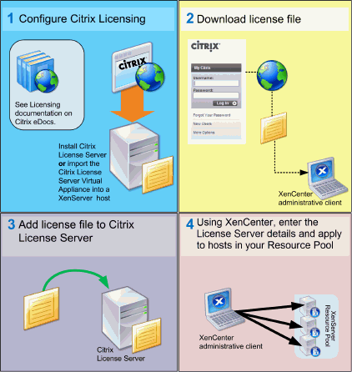

**Licensing XenServer**

**Q.** **Where can I purchase a XenServer License?**

A: You can purchase a XenServer License from <http://citrix.com/buy>

**Q. How do I apply a XenServer License?**

A: XenServer requires a License Server. After licensing XenServer you will be provided with a .LIC license key. This license key should be installed on either:

* 1. a Windows server running the Citrix License Server software   
     or
  2. The Citrix License Server virtual appliance.   
       
     During the XenServer boot process, each host attempts to check out a license.
* **How many licenses do I need to license my resource pool?**  
  A: XenServer is licensed on a *per-CPU socket* basis. For a host to be considered licensed all hosts in the pool must be licensed. XenServer only counts populated CPU sockets.
* can use the Citrix License Server to view the number of available licenses displayed in the *License Administration Console Dashboard*.

**Q. Will I lose my Virtual Machine (VM) if my license expires?**

A: No, you will not lose any VMs or their data.

**Q. What happens if I have a licensed pool and the License Server becomes unavailable?**

A. If a XenServer installation has previously been licensed, the license has not expired and yet the License Server is unavailable, then customers will receive a *grace* period of 30 days at the licensing level that was applied previously.

**Q**. **I am upgrading to XenServer 6.2.0 from an Advanced/Enterprise or Platinum edition of 6.1.0; do I have to pay again?**

A. If you have active Citrix Subscription Advantage (SA), you can trade each per-host license for two per-socket licenses. You can trade in your licenses using the **My Account section** of the Citrix.com website. In the **All Licensing Tools** section, click **Upgrade**. If your SA has expired, then you can continue to use the unlicensed version of XenServer 6.2.0. However, unless you purchase SA, you will be unable to apply hotfixes using XenCenter and will be ineligible to receive Support.

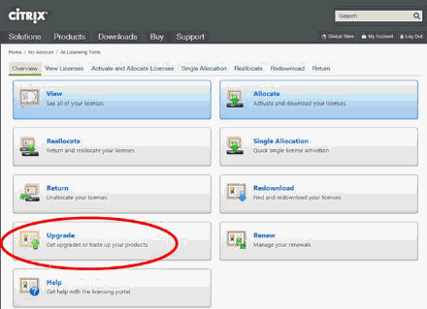

**Citrix License Servers**

**Q: Which License Servers can I use with XenServer?**

A: You can use both the Citrix License Server software (on a server running Microsoft Windows), or the Linux-based Citrix License Server virtual appliance.

**Q: Can I use an existing Citrix License Server for XenServer?**

A: Yes. If your License Server is running version 11.6.1 or higher then it will be compatible with XenServer.

**Q: How do import my license onto the Citrix License Server?**

A: Follow the procedure [here](http://support.citrix.com/proddocs/topic/licensing-1110/lic-lmadmin-import-licenses.html).

**Q: Can I run the License Server on my XenServer pool?**

A: Yes. You can install the Citrix License Server software on a Windows VM or import the Linux-based Citrix License Server virtual appliance. For ease of deployment, the Citrix License Server software is pre-installed on this Virtual Appliance, and it can run as a VM in your XenServer pool. XenServer operates with a ‘grace’ license until the License Server is able to boot.

**Q: Can I use the Windows version of the Citrix License Server with Xenserver?**

Q: Yes.

**Q Can I install Licenses for other Citrix products on a Citrix License Server virtual appliance, or on the Citrix License Server software installed on Windows.**

A: The Citrix License Server virtual appliance is only supported for XenServer licenses. However, the Citrix License Server software for Windows supports all Citrix licenses.

**Licensing a XenServer Pool**

**Q: How do I apply a license to all the hosts using XenCenter?**

A: Follow this procedure to apply a license:

1. On the Tools menu, click License Manager.

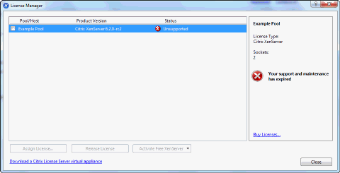

1. Select the Pool or Hosts you would like to license, and then click **Assign License**.
2. In the **Apply License** dialog, specify the **Edition** type you want to assign to the host, and enter the hostname or IP address of the License Server, as shown below:

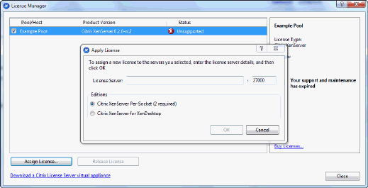

**Q: Can I apply a license without using XenCenter?**

A: Yes, you can use the xe CLI. Run the host-apply-edition command. For example, enter the following to license a host:

xe host-apply-edition edition=free|per-socket|xendesktop \ license-server-address=<license_server_address> host-uuid=<uuid_of_host> \ license-server-port=<license_server_port>

To license a pool, use the pool-apply-edition command. For example:

xe pool-apply-edition edition=free|per-socket|xendesktop \ license-server-address=<license_server_address> pool-uuid=<uuid_of_pool> \ license-server-port=<license_server_port>

**Other Questions**

**Q: How do I get a license to evaluate XenServer?**

A: You do not need a license to evaluate XenServer – all features are available in the unlicensed version.

**More information**

* For more information about the XenServer 6.2.0 release, refer to [CTX137826 - XenServer 6.2.0 Release Notes](http://support.citrix.com/article/CTX137826)
* For frequently asked questions about XenServer, refer to [CTX137836 - XenServer 6.2.0 Technical FAQ](http://support.citrix.com/article/CTX137836)
* Any non-technical issues with XenServer including, Subscription Advantage program support, licensing, administrative support, and order confirmation, can be raised through [Citrix Customer Service](http://www.citrix.com/support/customer-service.html).

**This document applies to:**

* [XenServer 6.2.0](http://support.citrix.com/product/xens/v6.2.0/)